Design optimization:
- Draw schematic of forces being applied to robot -- include parameters
  - Inkscape schematic done. (Just update with final design)
  - 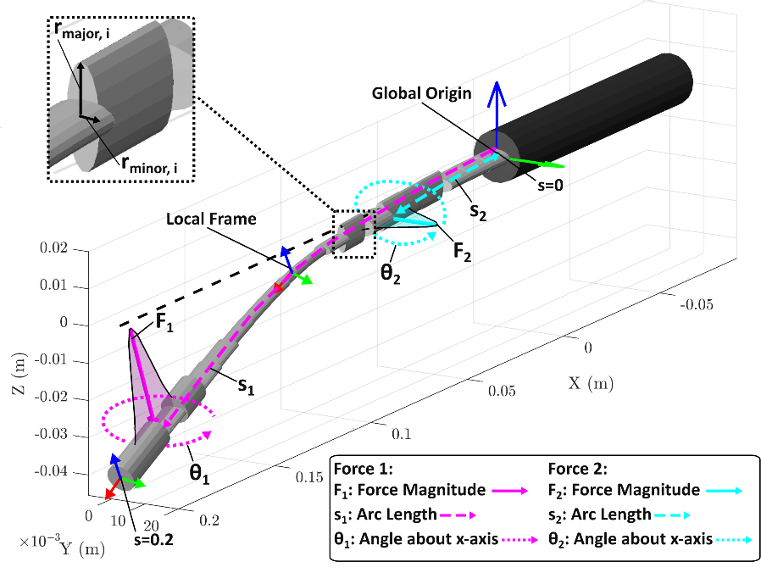
- Write out assumptions you are making
  - See thesis
- How close together can we assume forces to be? Should do an analysis on this rather than picking a value.

- Show analysis for both single force and two forces—in terms of the Jacobian.
  - Singular value decomposition MATLAB script works for single and two forces.
- Output scaling—think about wording + how to experimentally calculate this
  - Re-worded
    - “noise-whitened Jacobian”

- Assumptions being made on robot kinematics?
  - See thesis
- Think about how the tendon force information is used in the force estimation
  - Tendon force is not explicit in the equation, but implicitly determines the entries of (J), acting as a stiffness tuner.
  - Zero tendon tension yields the soft, best-case force estimation. Actuation increases stiffness and degrades estimation.
  - Optimizing only at zero tension targets the easiest condition, so random tendon tensions should be included in the test set to capture stiffened behavior.
- What would a "naive elliptical design" look like?
  - A naïve design for two force estimation is the thick, skinny, thick design, where the skinny section is slightly elliptical. The reason this design works is because it has multiple mechanical properties which decouple the two forces. 1) The thick, skinny, thick design means that proximal forces create almost no axial force Fx, and no torsion Tx. Whereby a distal force creates axial force Fx and a small torsion Tx due to the skinny ellipse. The result is that the Fx and Tx channels are reserved exclusively for the distal force allowing efficient decoupling.
- balance force estimation and stiffness? -- add stiffness information as a tip displacement constraint potentially or max strain
  - To ensure the design optimization does not converge on an unrealistic design which would easily snap under load, we include a linear constraint on stiffness. At each of the 20 links in our beam, we measure the internal bending moments Ty and Tz and calculate the corresponding max vonmises stress. We then compare the vonmises stress to the material yield strength to get a factor of safety F.O.S. For 20 links we then have an array of 20 F.O.S. The optimizer then enforces that the worst-case F.O.S is above 1. This ensures that at the weakest link in our design will not plastically deform.
- How fast is the estimation? What is our goal for speed?
  - Variable strain approach is often faster than piecewise linear strain (PLS) and piecewise constant strain (PCS) as you can model simple geometry, highly non-linear beam deflection with less quadrature points. However, since I am using multiple links with different complex geometries PLS provides the best balance between accuracy and speed.
  - With a good initial guess the estimation takes < 10 seconds
  - We could potentially get real time estimation using a C.N.N
- What is more important arc length (s), global position (x,y,z) or both?

